**Design Document for:**

# Nameless Eldritch

**Embrace the chaos unfolding in this world of horror.**

All work Copyright ©2020

Written by Morgan Thomas, Krzysztof Wisniewski, Luke Davies, Joseph Thomas

Version # 1.00

Sunday, January 10, 2021Table of Contents

Nameless Eldritch 1

Design History 4

Game Overview 5

Philosophy 5

Common Questions 5

What is the game? 5

Why create this game? 5

Where does the game take place? 5

What do I control? 5

How many characters do I control? 5

What is the main focus? 5

What’s different? 5

Feature Set 6

General Features 6

Gameplay 6

The Game World (Krzysztof) 7

Overview 7

World Feature #1 7

World Feature #2 7

The Physical World 7

Overview 7

Key Locations 7

Travel 7

Scale 7

Objects 7

Time 8

Rendering System 8

Overview 8

2D/3D Rendering 8

Camera 8

Overview 8

Camera Detail #1 8

Game Engine 8

Overview 8

Game Engine Detail #1 8

Water 8

Collision Detection 8

Overview 9

World Layout Detail: Puzzles 9

World Layout Detail: Enemies 9

Game Characters (Luke Davies) 10

Overview 10

Creating a Character 10

Enemies and Monsters 10

User Interface (Luke Davies) 11

Overview 11

User Interface Detail: Text Input 11

User Interface Detail: Inventory 11

Overview 12

Weapons Details: Collecting weapons 12

Weapons Details: Most Powerful Weapon 12

Musical Scores and Sound Effects (M Thomas) 13

Overview 13

Sound Format 13

Sound Design 13

Musical Scores 13

Sound Effects 14

Single-Player Game (Luke Davies) 15

Overview 15

Story 15

Hours of Gameplay 15

Victory Conditions 15

Credits... 16

Coding – Joseph Thomas 16

Design – Luke Davies 16

Graphics – Krzysztof Wisniewski 16

Sound – Morgan Thomas 16

Appendix 17

User Interface Appendix 17

# Design History

This section records game progress from prototype through to initial release version and subsequent updates.

1. Initial game design completed to include five gameplay zones.
2. Enemy designs to include Knight, Goblin, Pink Witch and Skeleton.
3. Graphics created for all enemies, main menu, player and street.
4. Sound created for all background atmosphere within zones. All foreground interaction sounds created.
5. Coding for movement within the zones and text interactions completed.
6. Coding for inclusion of background sound zone 1 completed.
7. Debugging of unresponsive Pygame window ongoing.

# Game Overview

## Philosophy

Nameless Eldritch is a text-controlled puzzle game, in which the player moves around the world and solve puzzles using common English. The player looks and interacts with the world around them to progress through the eldritch horror infested world and hopefully try to stop the takeover.

The setting of this world is split between two worlds, the main world in which eldritch horrors have begun to overrun and ruin the world. You will mainly explore an overrun city. The alternate world will take place in the same environment but in a world where the eldritch horror has completely taken over and destroyed the world.

One of the main aspects of the game will be the ability to access the alternate version of the world. Access to the alternate world will be used as a tool to solve many of the puzzles presented to the player.

## Common Questions

### What is the game?

A text-controlled puzzle game with multiple choice options at each interaction.

### Why create this game?

Created as a group project with aspects of the project split between members of the group.

### Where does the game take place?

Within a world or alternate world environment.

### What do I control?

You control the main character. You will enter text to decide on how you wish to progress from a selection of options to control this character.

### How many characters do I control?

You control one character, who is the main character.

### What is the main focus?

To progress towards the end zone where you will need to defeat the final enemy to successfully complete the game.

### What’s different?

The game takes place in two worlds, the real world and an alternate world. The player will need to switch between these two worlds to progress.

# Feature Set

## General Features

Large explorable world.

2D graphics.

Pixel art.

Alternate world system.

Puzzles that will have to be completed to progress.

## Gameplay

Text based adventure.

Puzzle solving.

Turn based combat.

Exploration.

Switching between worlds.

# The Game World

## Overview

The first world will look normal and more livable without any big destructions and much easier to fight in. Alternative world will be much darker and more difficult to fight in. There will be less resources and much more dangerous enemies to fight. Player will be able to find more valuable items in the alternative world/

## World Feature #1

Moving to another world player will be able to do. Player will use this function to solve differed puzzles in the game and to progress in the game. Player will be able to collect different items from both of words.

## World Feature #2

Player will be able to solve different puzzles to progress in the game. Puzzles will be interesting and fun for the player do to as they will be easy enough to solve without any big problems. IF the player has tried many times and failed then game will give him a pass to the game.

## The Physical World

### Overview

There are two different worlds and player will be able to move from one world to another to accomplish their objectives. First world is more like normal world where he will be able to meet normal people and fight different enemies. Second world is much darker and different world from the first one, player will be needing to fight with different harder enemies.

There will be different puzzles in where player will need to complete correctly to move to another map and to complete another puzzle and kill all enemies that user see. Puzzles will be

### Key Locations

The key location are tiles where puzzles are containing as those puzzles will be needing to be completed to move forward to another map. Another key location is where user will need to be to move to another location end of the map so user will be able to move to another map.

### Travel

Player will be able to move around using a tiles baes system, this means that player will be moving around tile by tile to go to different objectives that player will have. At the end of each map there will be specific tile in which player will be needing to pass to go to another map.

### Scale

There will be in total 6 zones in which will contain multiple maps. This means that player will be able to move around and view all zones that are available. There will be another world in the player will be able to move around with the same size of maps and zones.

### Objects

The object of the game is to complete puzzles game in which the player will be able to move forward. Throughout the game player will be needing to pass enemies to go to final boss in which game ends.

Player will be able to find many objects like chest that will have random items. In the chest player will be able to find different types of weapons with different strengths and with different statistics.

There are random coins in different location that user will be able to find all around maps and different world.

### Time

Time is set up to a specific time for all of the maps. This way the is no need for alternative graphics created.

## Rendering System

### Overview

The render method for this game is a surface object that it's in the text. This way the images can be shown in the game.

### 2D/3D Rendering

It will be used a 2D pygame engine.

## Camera

### Overview

The camera will be from top of view in which player will be able to move and to see bigger map. Player will be able to zoom and zoom out from the main character. This way player will be able to see different items that he can use or interact with.

### Camera Detail #1

Camera will zoom in automatically when player begin fight with enemies.

## Game Engine

### 

### Overview

Pygame is a engine where user will be able to create build any complex or simple game using a python. This pygame engine supports collisions, game objects and much more. This means that engine will provide us many features that our game is going to need to have to be playable or even to develop in.

### Game Engine Detail #1

The game will have map code of things that each zone will have. It will create any objects or items that the code map has. This way user will be able to find any items or object to interact with.

### Water

There will be no moveable water. The water will be a static graphics used in the background.

### Collision Detection

The game will detect any collision between different tiles, and it will stop main character to go any further

**The World Layout**

## Overview

The game world will be split up into five zones, the street, the sewers, the park, an additional street level and the church. Each of these zones is being designed differently and the aim is for each zone to feel unique. For example, the park should be an open zone whereas the sewers should be maze like and narrow.

The world is being designed using a tile-based system. Tiles could be enemy tiles, item tiles, weapon tiles, start and end tiles etc. This is also how the game will play, and the player will be able to move to the next tile in any direction using text.

## World Layout Detail: Puzzles

The puzzles implemented into the game will be designed to be integrated into the zones. For example, in the maze-like sewer, players might have to explore to find hidden clues. In the park level, players might have a puzzle involving statues in the park.

## World Layout Detail: Enemies

Just like the puzzles, the enemies will also be integrated into the zones. An enemy might block a path that leads to an item, encouraging the player to engage in combat with the enemy using the combat system.

# Game Characters

## Overview

The characters in the game are mainly enemies, except for the main character who is controlled by the play. There may also be a shop keeper character developed if there is enough time to do so.

## Creating a Character

You cannot customize the appearance of the character. However, you can choose what weapons and items you decide to use as you progress through the game. While many games, especially newer games, do provide some character customization, we felt that it was not necessary in our game. However, if we had more time to make the game and add extra features, this would be something we would implement.

## Enemies and Monsters

In the game, there will be a variety of enemies and monsters. They will all be designed to provide a different challenge to the player and block their progression in a different way.

Rat: This basic enemy should give the player an introduction to combat.

Plant: This enemy should block the players progression as part of a puzzle. The plant will drop a clue required to solve a puzzle on defeat.

Statue: This enemy can only be fought and defeated in the alternate world. In the real world they will block progression by blocking paths until they are defeated.

Goblin: Another basic enemy to add variety to combat.

Witch: Defeating this enemy will give the player healing items, giving them incentive to fight witches that they encounter on their journey.

Skeleton: This enemy is also only fightable in the alternate world, appearing as bones in the real world.

# User Interface

## Overview

The user interface will display on screen information about the tile that the player is currently on. It should also display graphical representation of the current area or enemy that the player is fighting. The user interface may also display a list of actions that the user can take, such as attacking if an enemy is present.

## User Interface Detail: Text Input

There will be a section on the user interface that allows the user to type in a command. This is how the user will play the game, by typing into this section of the UI.

## User Interface Detail: Inventory

There will be an inventory system implemented into the game, which will allow the player to switch out and equip different items and weapons. This will be represented on the UI if the player decides to open the inventory. This could be in the format of a text list of all the items that the player currently has.

**Weapons**

## Overview

The game will feature a system where the player can equip a variety of different weapons. This is a feature that is present in many popular adventure games, and a feature that brings more enjoyment to the games. We feel therefore that we should implement this into our game.

## Weapons Details: Collecting weapons

The player will be able to collect enemies by defeating certain enemies or opening treasures. It is intended that some weapons will be in hard-to-reach areas that will give the player incentive to go to them.

## Weapons Details: Most Powerful Weapon

A feature that will make the game easier to play that we will implement is allowing the user to equip their most powerful weapon.

# Musical Scores and Sound Effects

## Overview

The background musical scores are to be designed to enhance the atmosphere of the gameplay. The foreground/global sounds will back up all player interactions throughout the game.

## Sound Format

The ‘ogg-vorbis’ sound format will be used as it is readily supported by numerous platforms. It also produces a higher quality of sound than that of other equivalent sized file formats.

## Sound Design

The background sounds will be designed to create an atmosphere that matches the location of the player. The ‘normal world’ will have a more upbeat background sound, but with elements that attempt to portray the feeling that something is going to change. The ‘alternate world’ will have an eerie background sound with elements that suggest enemies could be close by.

Foreground or global sounds will back up interactions such as battles, running, walking, gathering coins, health-boosts and others.

## Musical Scores

The background sounds for each of the zones 1 to 5 is shown in the table below...

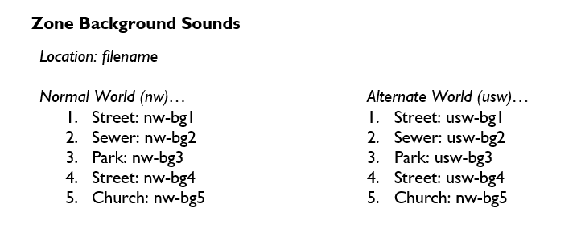

## Sound Effects

The foreground/global sounds that will be used throughout the game are shown in the table below...

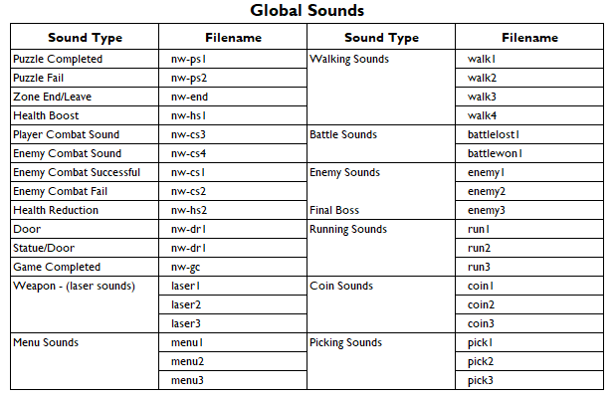

# Single-Player Game

## Overview

The game is a single player game only, with no capabilities for multiplayer. In the single player game, the player will traverse five zones in a city, both in the real world and an eldritch dimension.

## Story

The general story of the game revolves around a city overtaken by eldritch horrors. However, the focus of the game is on gameplay rather than the story. This also means that the story should be simple and easy to follow, with a clear goal and way to win.

## Hours of Gameplay

We estimate that the game will take around fifteen minutes to half an hour to fully complete at a normal pace.

## Victory Conditions

The player will win the game by completing all of the zones.

# Credits...

## Coding – Joseph Thomas

## Design – Luke Davies

## Graphics – Krzysztof Wisniewski

## Sound – Morgan Thomas

# Appendix

This section contains additional information to assist gameplay.

# User Interface Appendix

